# GSTR 2A Excel files Consolidation to check input tax credit

This file contains all the steps and information that was recorded to help you describe the steps in using the project

# The project was created for BFSI Sector to consolidate downloaded GSTR 2A from GST website through Excel VBA accuracy and speed as the volume of such files is huge and accuracy is of utmost important to match Input Tax Credit.

# Steps

Previous Next

**Step 1: (‎31-‎05-‎2019 16:55:49)** User left click on "Rectangle (shape)" in "Combine Excel Files 4.xlsm - Excel"

**To clear previous information in the sheet.**

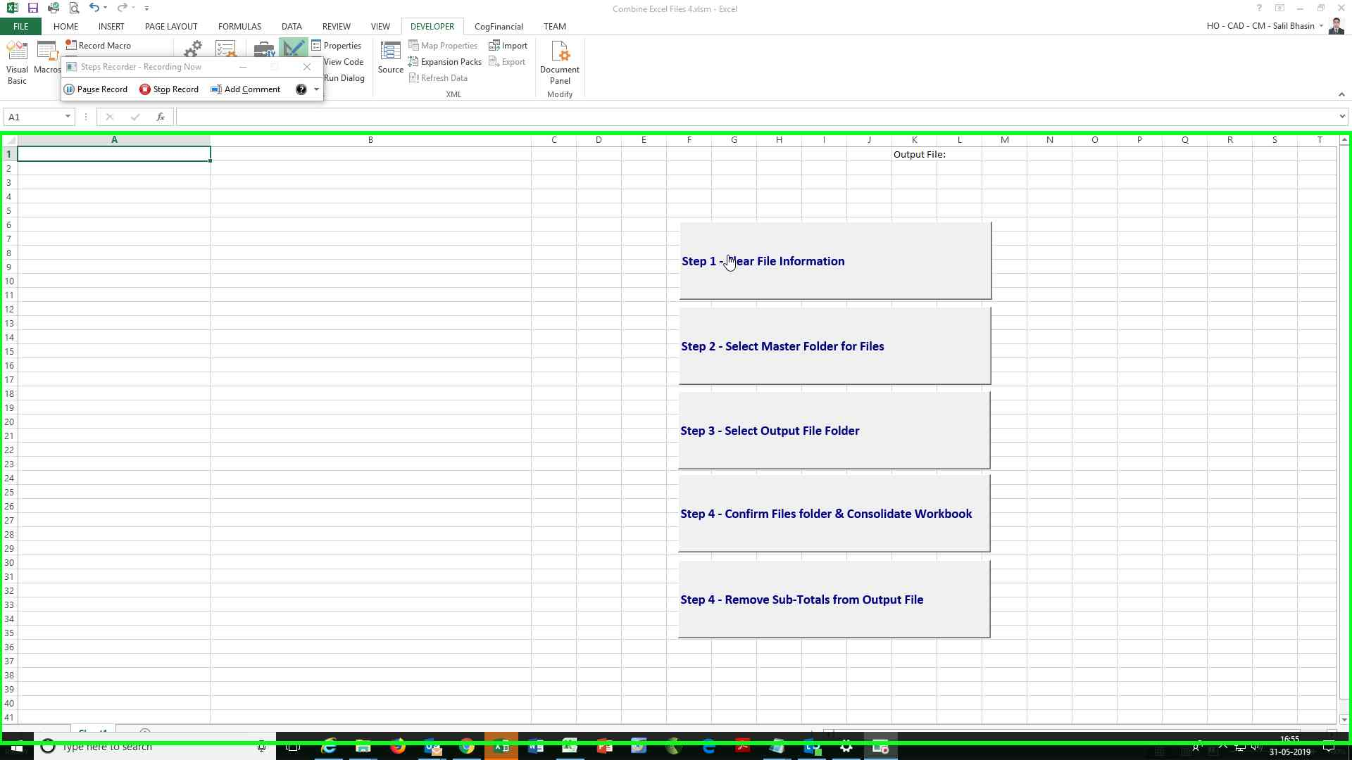Step 1 screenshot.

Previous Next

**Step 2: (‎31-‎05-‎2019 16:55:50)** User left click on "Rectangle (shape)" in "Combine Excel Files 4.xlsm - Excel"

**Select the folder containing all the downloaded excel files.**

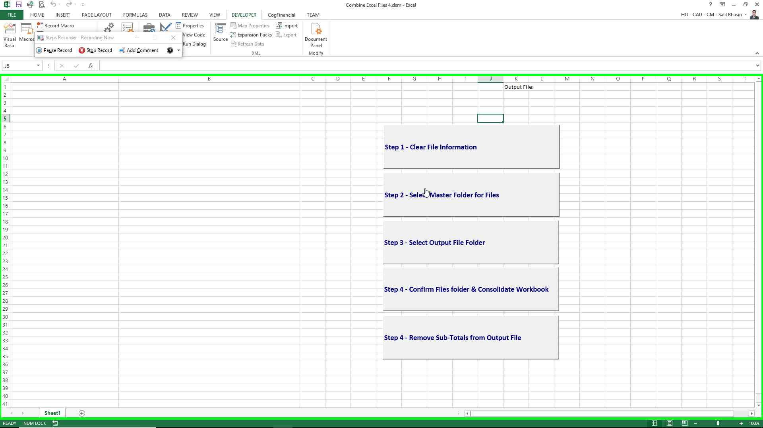Step 2 screenshot.

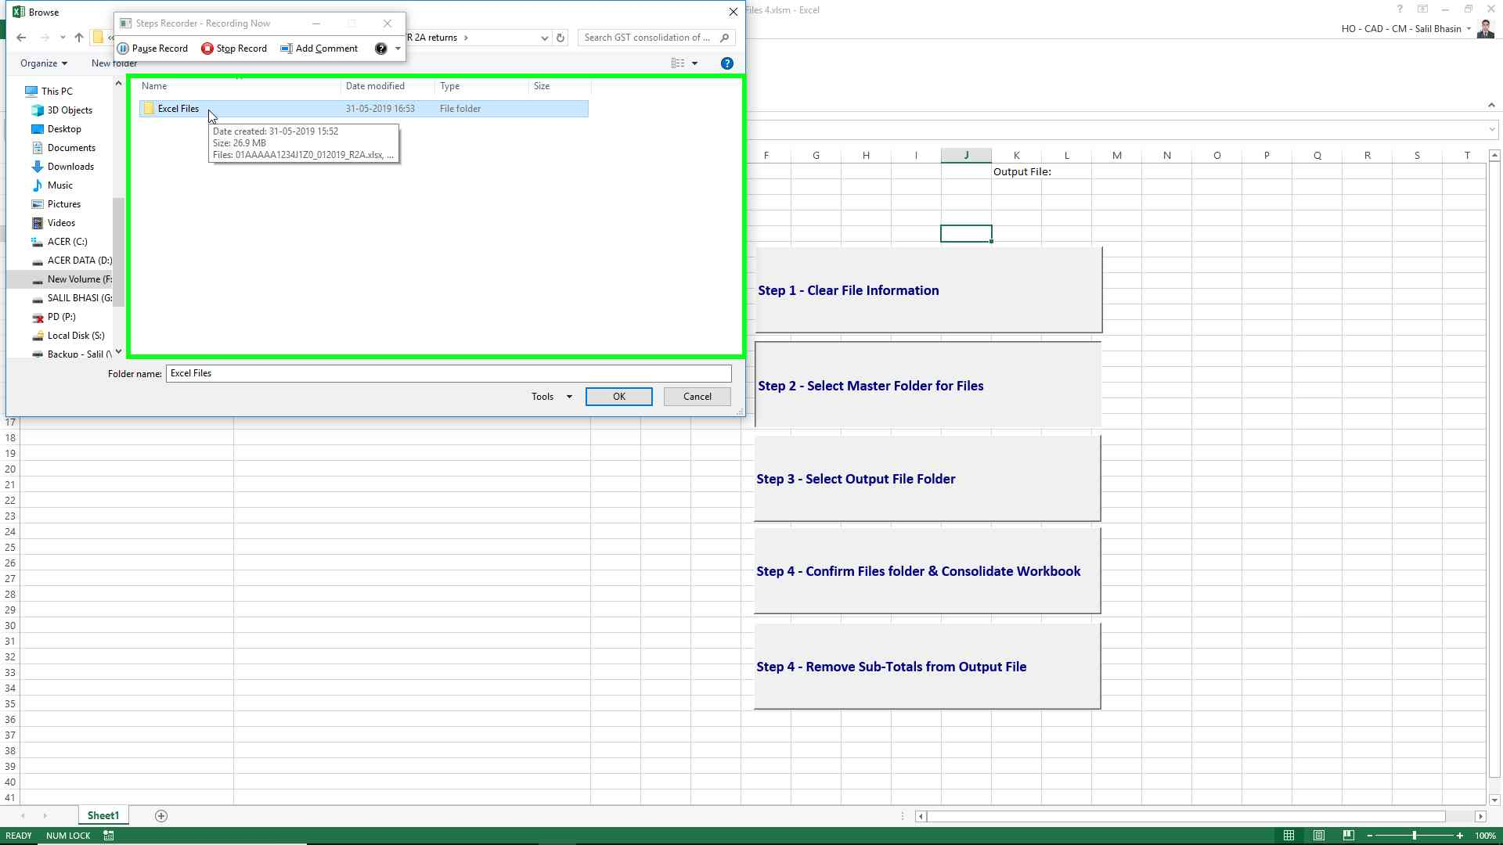Step 8 screenshot.

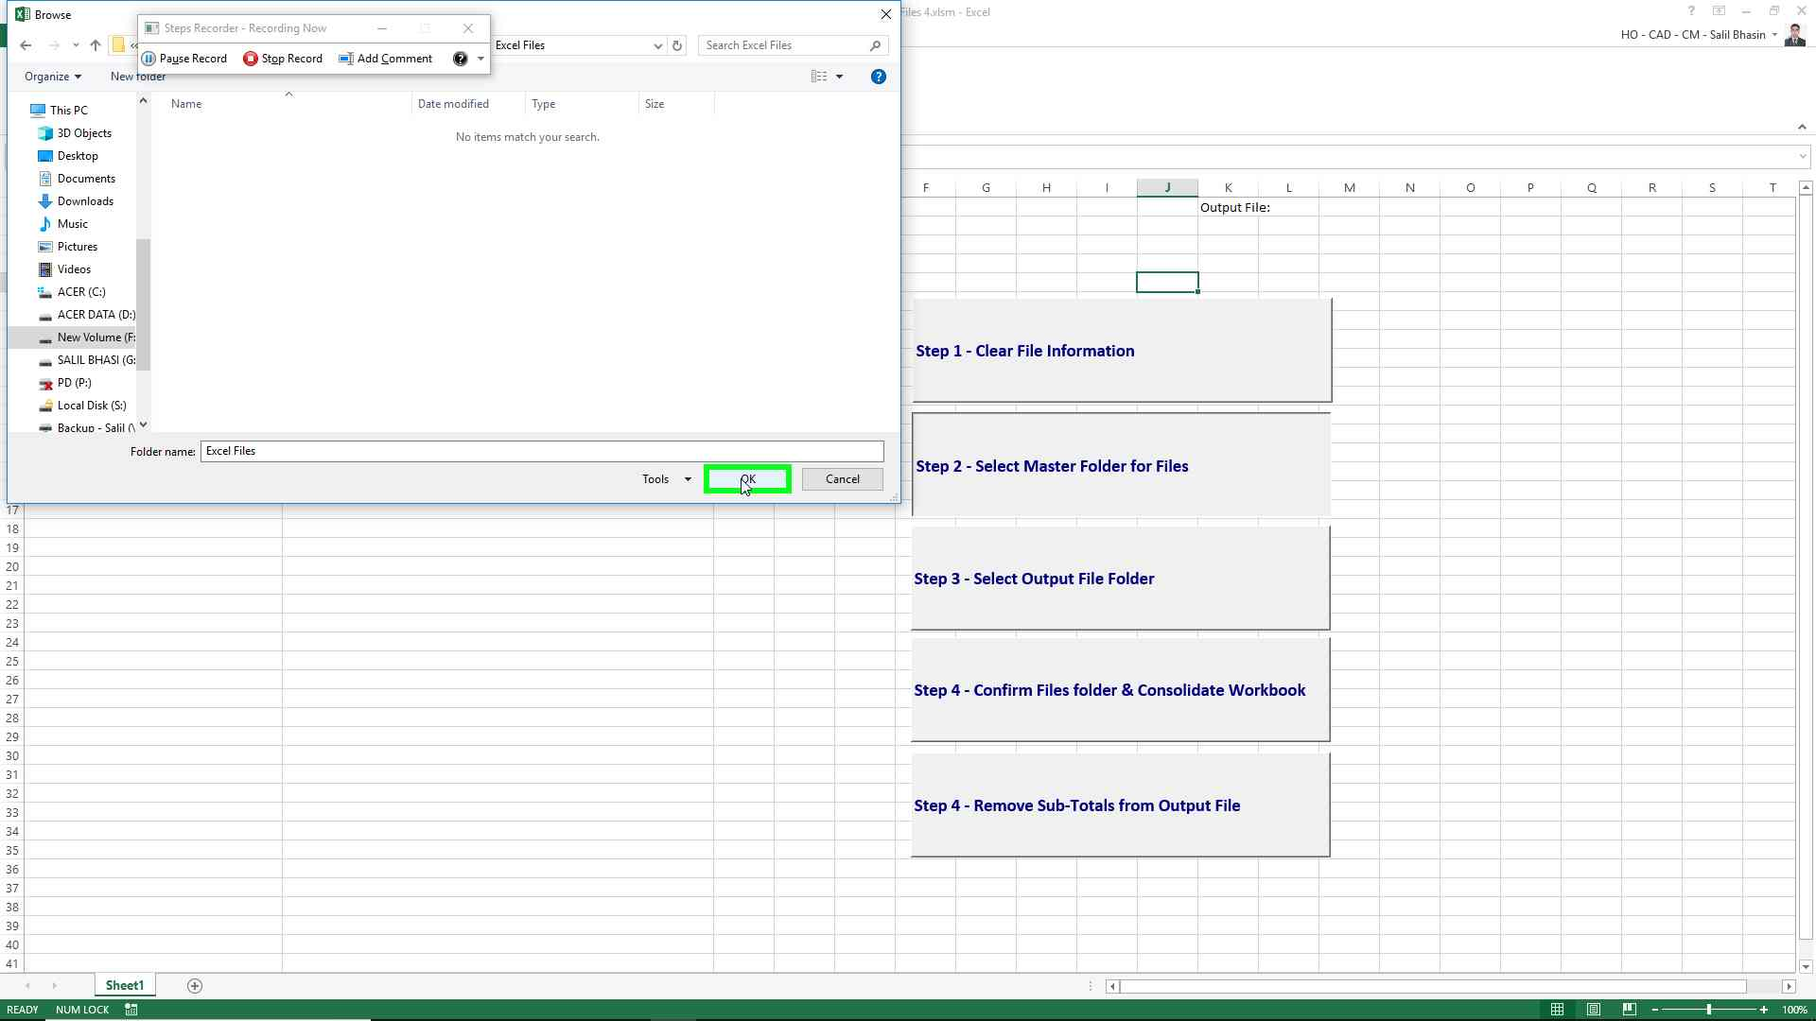Step 9 screenshot.

Previous Next

**Step 10: (‎31-‎05-‎2019 16:56:09)** User left click on "Rectangle (shape)" in "Combine Excel Files 4.xlsm - Excel"

**Select the folder containing “Output.xlsx” File**

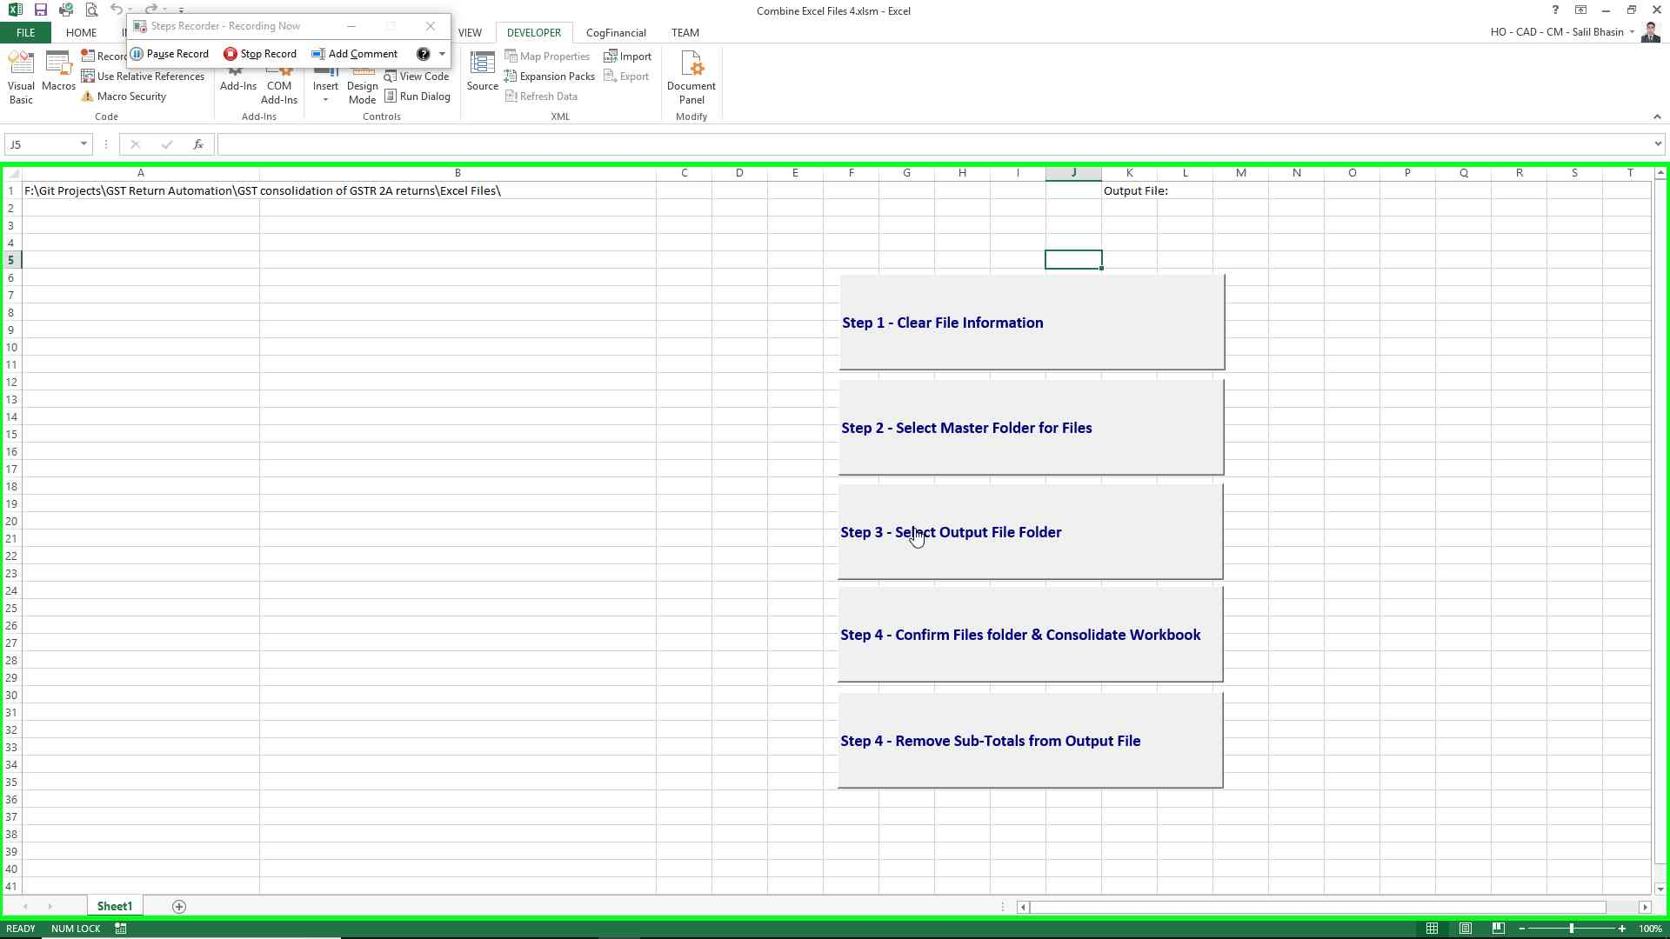Step 10 screenshot.

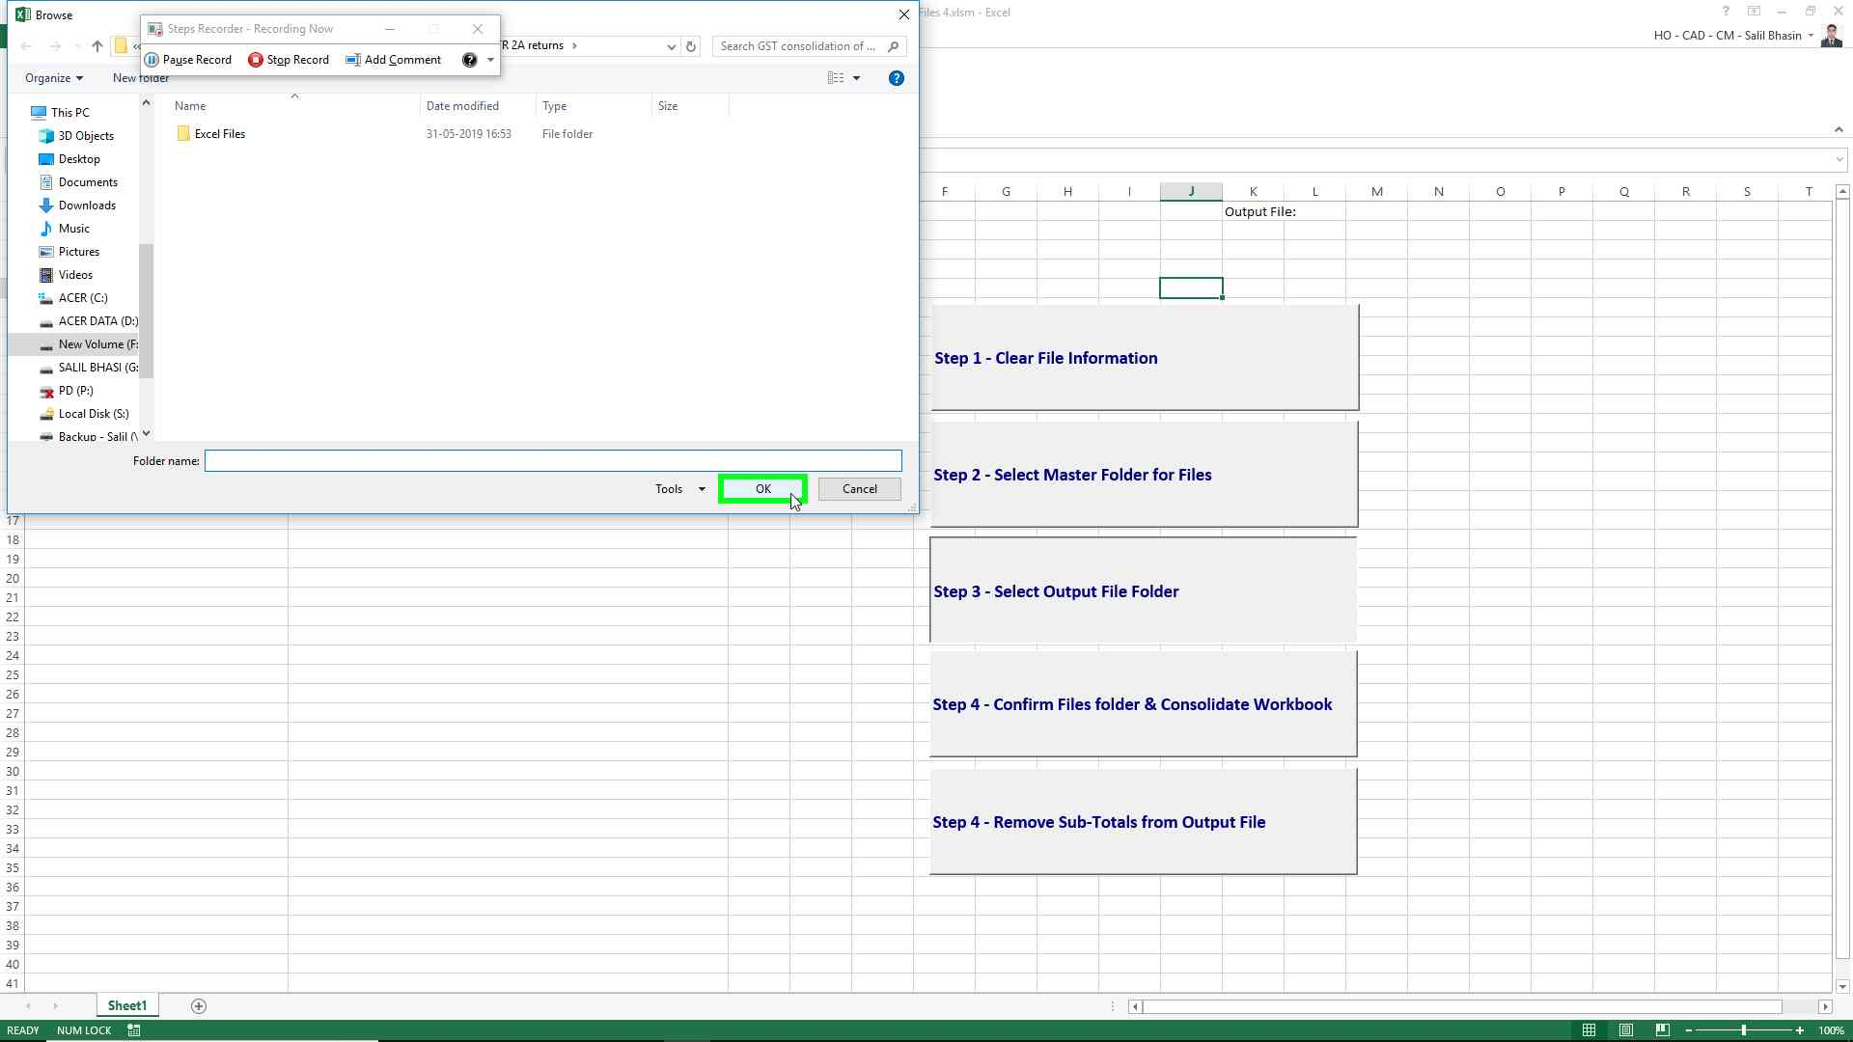Step 11 screenshot.

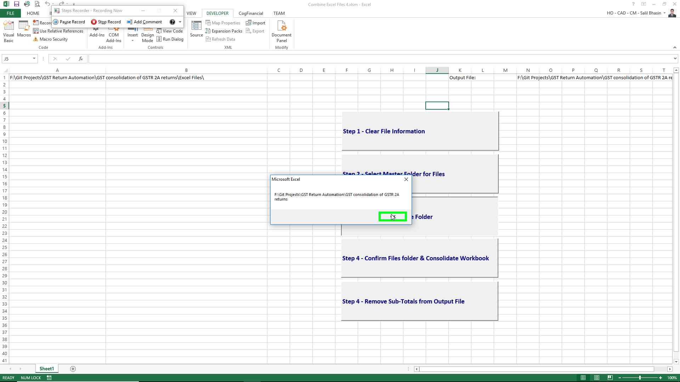Step 12 screenshot.

Previous Next

**Step 13: (‎31-‎05-‎2019 16:56:16)** User left click on "Rectangle (shape)" in "Combine Excel Files 4.xlsm - Excel"

**To confirm the files folder and start consolidation**

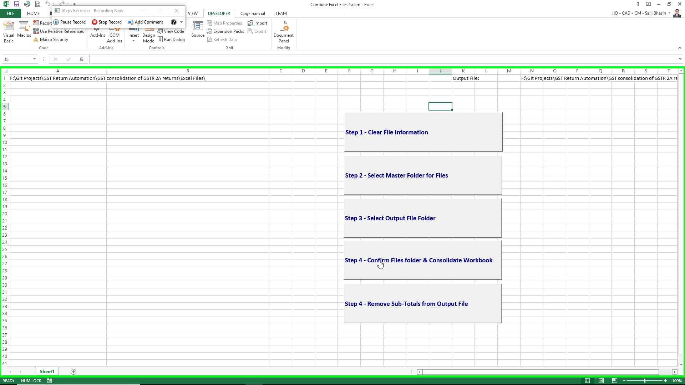Step 13 screenshot.

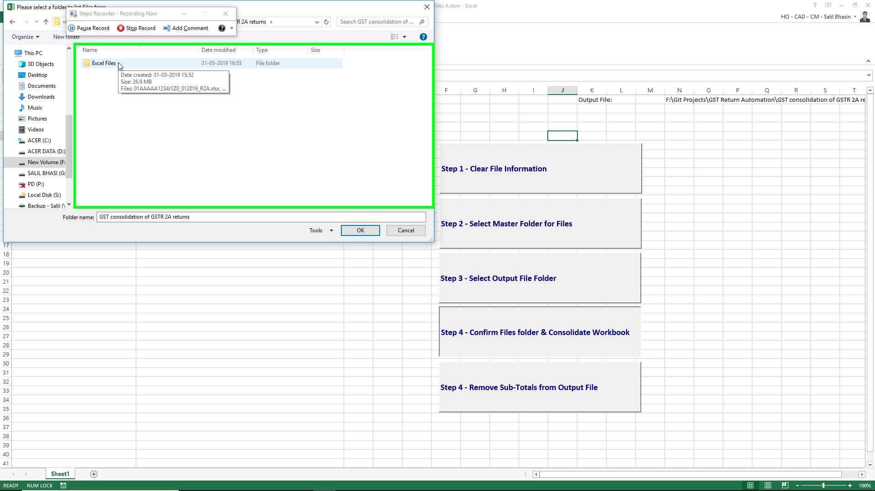Step 18 screenshot.

**File Names are populated in the xlsm file and Data will be consolidated in the Output.xlsx file.**

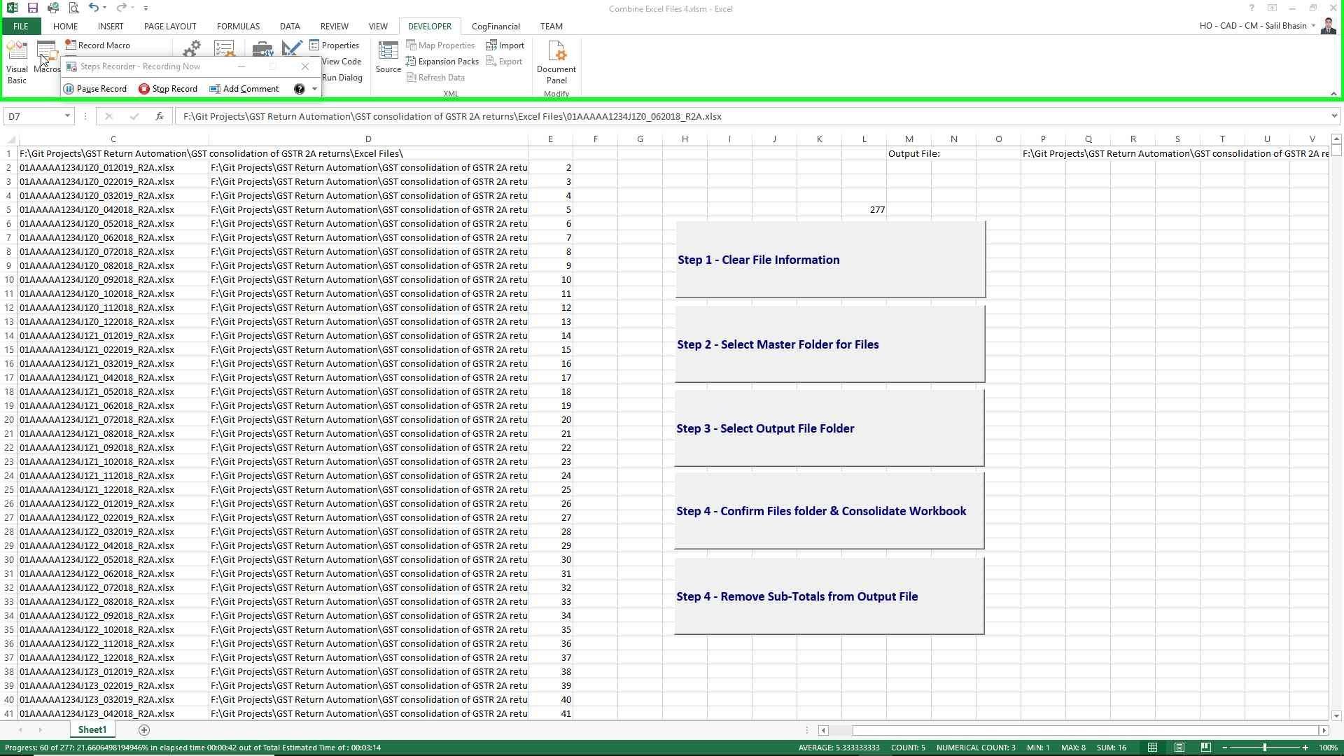

**To further process the output file i.e. removing subtotals and spaces between entries other macros can be used as depicted below**

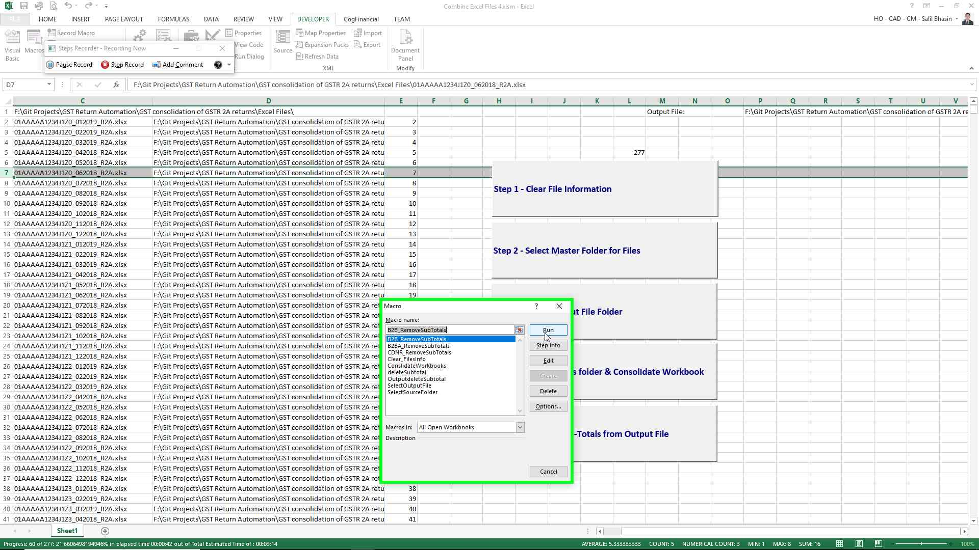

Previous Next